**DEVOPS TOOLS AUTO BRINGUP TEST SCENARIO RESULTS OF CIRRUS SERVER**

Have rebooted cirrus m/c and devops tools are auto bringe up & find below screenshots of the results and same configuration is setup in prod devops server also.

We can check this scenario without reboot also by using commands whether tolls will autobringup or not and find below screen shots of output of the same from devops server. (Checked in devops server and getting success result.)

AFTER REBOOT CIRRUS M/C:

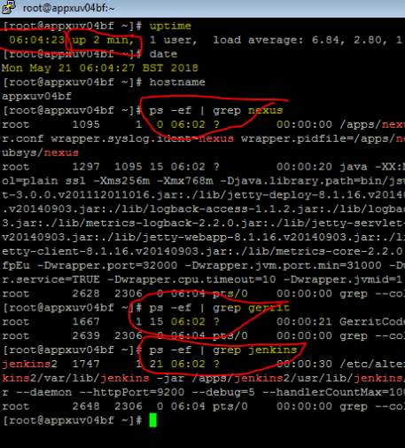

AUTO BRINGUP CONFIGURATION FROM CIRRUS:

Nexus:

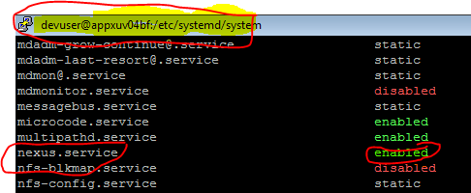

Jenkins & Gerrit:

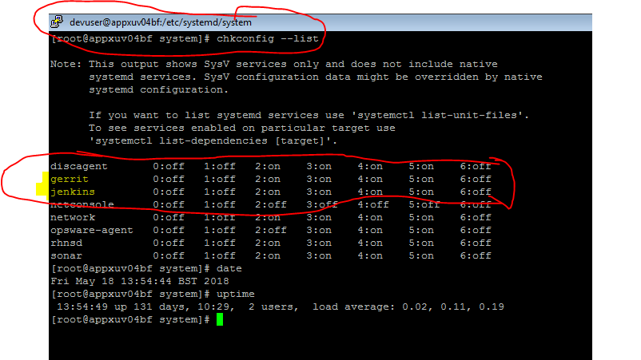

AUTO BRINGUP CONFIGURATIONS FROM DEVOPS PROD M/C:

Jenkins & Gerrit:

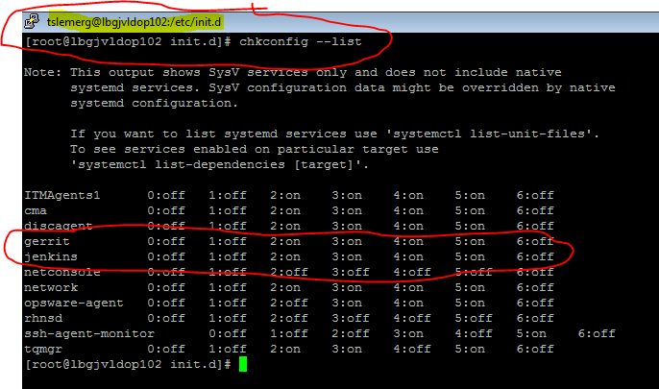

Nexus:

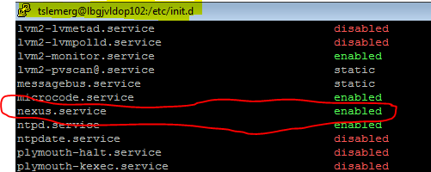

HAVE CHECKED DEVOPS PROD WITHOUT REBOOT WHERTHER TOOLS WILL AUTO BRINGUP OR NOT BELOW IS THE RESULT:

